Unit 1 Lesson 8

**Video Games Developer**

**Description:**

A game designer is responsible for the creative and conceptual aspects of game development. They create the overall vision and design of a video game, focusing on gameplay mechanics, storylines, level design, and user experience. They must create a balance of elements like a challenge to be fun and create an engaging and enjoyable player experience. They are the creators of the gaming world, shaping the rules and environments that players interact with to create memorable and immersive gaming experiences.

**What they’re looking for:**

Looking for talented and gifted coders who can design and build the next generation of video games for the company. In this role, you will help debug and code the baseline of the game fix any bugs, and troubleshoot design issues. May also be asked to design the story of the game, the characters, and or levels. To have a successful career in developing games, you must have a strong understanding of design skills, lots of knowledge of coding software and to work within a team.

**Requirements:**

* **Bachelor’s degree in computer science**
* **Experience with full-cycle game design**
* **Understand programming languages involving C++, Java, and C**
* **Knowledge of trending games**
* **Creativity and technical skills**
* **Ability to debug code**
* **Ability to work in a team**

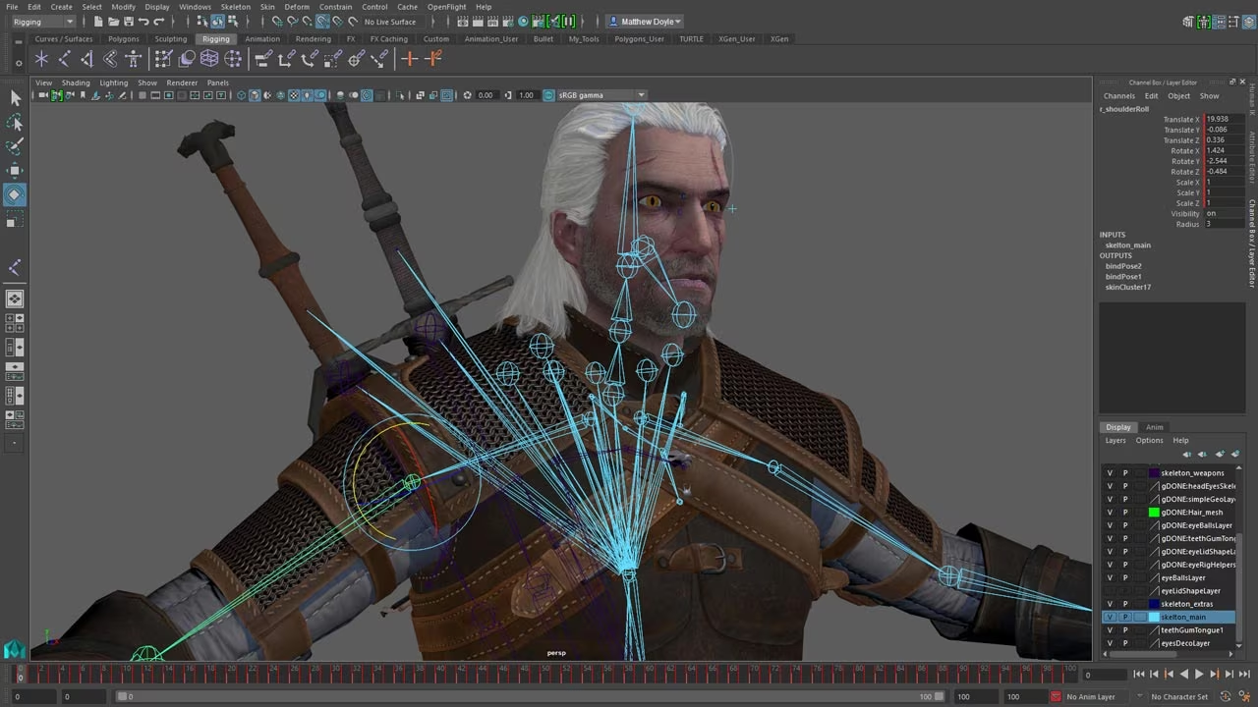

**Computer Science**

**Program Summary:**

In the Computer Science program, students will have the opportunity to equip themselves for future graduate studies and careers in the realm of Information Technology. Students will solve real-world computing problems with numerical analysis, data management systems, computer graphics, and artificial intelligence.

**University of Toronto: Scarborough Campus**

**Degrees: Honors Bachelor of Science**

**Full Time (4 years)**

**Tuition fees: CAD$29,195.50 (US$ 21,508) per year**

**Approximate Grade Requirements: Mid 90s**

**Academic Requirements:**

* **Calculus & Vectors (MCV4U)**
* **English (ENG4U)**
* **Advanced Functions (MHF4U)**



**Bibliography**

"Video Game Developer Job Description." Betterteam, [www.betterteam.com/video-game-developer-job-description](http://www.betterteam.com/video-game-developer-job-description). Accessed 6 October 2023.

"Computer Science Undergraduate Programs." Future.utoronto.ca, https://future.utoronto.ca/undergraduate-programs/computer-science/. Accessed 6 October 2023.

"Bachelor of Science (Honours) Computer Science." Hotcoursesabroad.com, https://www.hotcoursesabroad.com/study/course/canada/bachelor-of-science-honours-computer-science/57632006/program.html. Accessed 6 October 2023.